

Test Execution and Output Evidence
Makhanda Connect System
Information Systems III Systems Development Project 2026
Document ID MLINK-TE-001 | Version 0.1
Prepared by: [Insert group member names and student numbers]

Document Control
Field | Details
Document | M-LINK Test Execution and Output Evidence
Identifier | MLINK-TE-001
Related document | M-LINK Software Test Plan MLINK-TP-001
Version | 0.1
Execution period | Iterative development and final assessment preparation
Test team | M-LINK Development Team
Status | Draft evidence document awaiting final screenshots and exact execution dates

1 Purpose
This document provides visible evidence that the M-LINK system was tested. It records the test conditions, actions, expected outputs, observed outputs and pass results for the core functions identified in the Software Test Plan. Screenshot placeholders are included so the team can insert final browser or database evidence from the assessment build.

1.1 Evidence Rules
- Use screenshots from the final assessment build.
- Show the relevant page title, input or record and resulting output.
- Hide passwords, OTP values, database credentials and personal contact information.
- Use test accounts and test data rather than live municipal information.
- Keep each figure number and caption with its screenshot.
- Enter the exact execution date and tester initials before submission.

2 Test Environment
Item | Environment used
Application | M-LINK PHP web application using HTML, CSS and JavaScript
Database | MySQL relational database with controlled project data
Server | Local Windows development environment and university development web server
Client | Desktop web browser with network access
Accounts | Controlled resident, councillor, municipal staff, organisation and administrator accounts
Evidence | Browser output, system messages and database-state checks

3 Execution Summary
Test area | Executed | Passed | Failed | Blocked
Registration | 4 | 4 | 0 | 0
Authentication and access | 5 | 5 | 0 | 0
Account administration | 3 | 3 | 0 | 0
Ward councillor rules | 4 | 4 | 0 | 0
Municipal services | 3 | 3 | 0 | 0
Notices | 4 | 4 | 0 | 0
Incident tickets | 2 | 2 | 0 | 0
Profiles and passwords | 2 | 2 | 0 | 0
Reports and logout | 2 | 2 | 0 | 0

Recorded total: 29 executed, 29 passed, 0 failed and 0 blocked. These values reflect the execution record in the approved Test Plan and must be reconciled with the final signed test run if further changes are made.

4 Registration Output Testing

TC-REG-01 Valid resident registration
Field | Recorded test information
Precondition | A valid address-directory record and ward exist.
Input or test data | Valid name, unique email, 10-digit contact number, matching password and selected address.
Execution steps | Open registration, choose Resident, complete the form and submit.
Expected output | A user record and community_member record are created with active and verified status.
Observed output | The account was created, appeared in the system and was available for resident login.
Status | Pass

TC-REG-02 Invalid registration input
Field | Recorded test information
Precondition | Registration page is available.
Input or test data | Invalid email or contact number, or passwords that do not match.
Execution steps | Complete the form with invalid data and submit.
Expected output | Submission is rejected and clear validation feedback is displayed.
Observed output | The invalid submission was rejected and no usable account was created.
Status | Pass

TC-REG-03 Duplicate email prevention
Field | Recorded test information
Precondition | An account already exists for the test email.
Input or test data | The existing email address with otherwise valid data.
Execution steps | Submit a new registration using the existing email.
Expected output | The duplicate account is rejected.
Observed output | Duplicate registration was prevented.
Status | Pass

TC-REG-04 Valid organisation registration
Field | Recorded test information
Precondition | A valid address and ward exist.
Input or test data | Unique organisation email, organisation name, contact, address and matching password.
Execution steps | Open organisation registration, complete all fields and submit.
Expected output | User and organisation records are created as active and verified.
Observed output | The organisation account was created and could proceed to login.
Status | Pass

OUTPUT EVIDENCE PLACEHOLDER
Figure 1: Registration output evidence
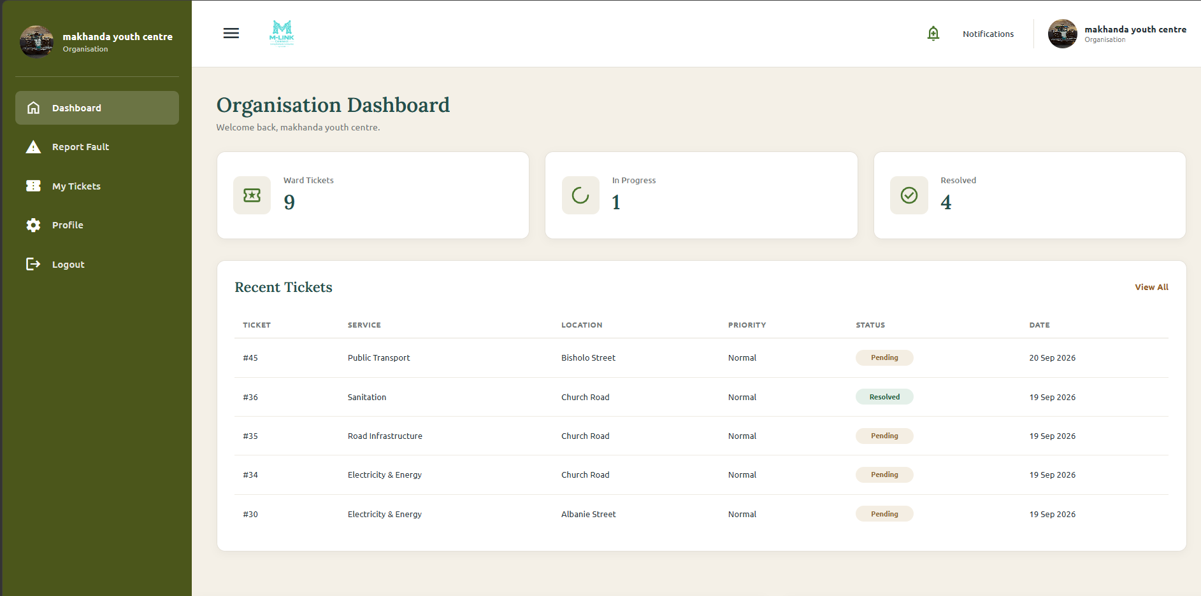
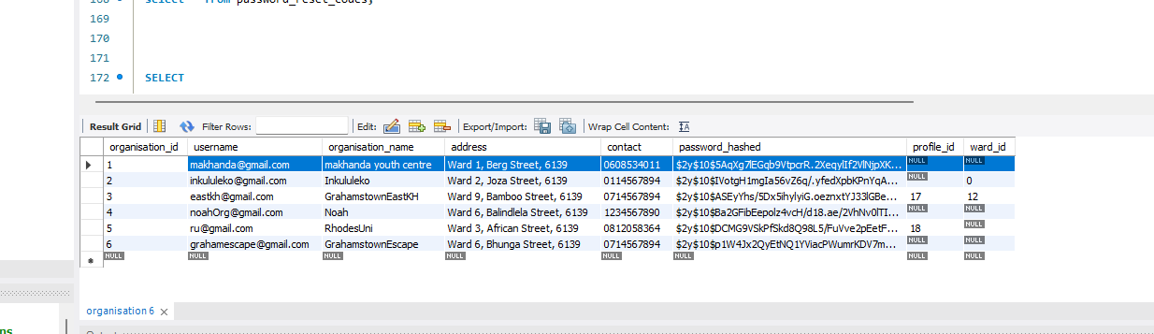
Figure 1: Registration output evidence

5 Authentication and Access Output Testing

TC-AUTH-01 Resident login
Field | Recorded test information
Precondition | An active and verified resident account exists.
Input or test data | Correct resident username and password.
Execution steps | Submit the login form.
Expected output | The resident dashboard opens.
Observed output | The correct resident dashboard was displayed.
Status | Pass

TC-AUTH-02 Incorrect password
Field | Recorded test information
Precondition | A registered account exists.
Input or test data | Correct username with an incorrect password.
Execution steps | Submit the login form.
Expected output | Authentication is rejected without sensitive information.
Observed output | Login was rejected using a safe error response.
Status | Pass

TC-AUTH-03 Inactive or unverified account
Field | Recorded test information
Precondition | A councillor or staff applicant is pending.
Input or test data | Correct credentials for the pending account.
Execution steps | Attempt to log in before authorisation.
Expected output | Access is denied until the account is activated.
Observed output | The pending account was blocked.
Status | Pass

TC-AUTH-04 Role-specific redirects
Field | Recorded test information
Precondition | Valid active accounts exist for supported roles.
Input or test data | Correct credentials for each role.
Execution steps | Log in as resident, councillor, staff, organisation and administrator.
Expected output | Each user reaches the correct role dashboard.
Observed output | Role redirects operated correctly for the tested accounts.
Status | Pass

TC-SEC-01 Protected administrator URL
Field | Recorded test information
Precondition | The tester is logged out or logged in with a non-admin role.
Input or test data | Direct administrator-page URL.
Execution steps | Enter the protected URL in the browser.
Expected output | The page refuses access.
Observed output | Protected access was refused.
Status | Pass

OUTPUT EVIDENCE PLACEHOLDER
Figure 2: Login and role output evidence
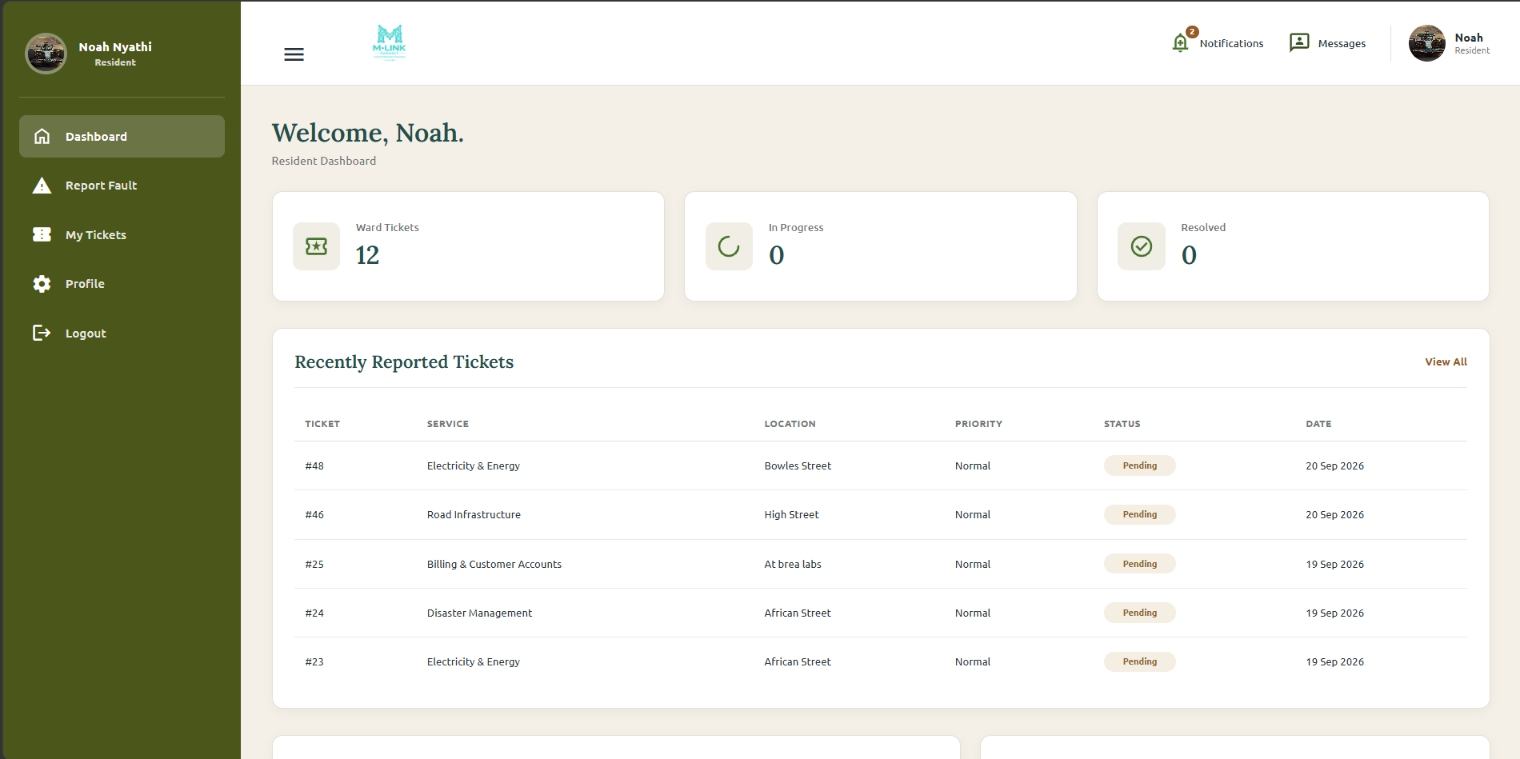
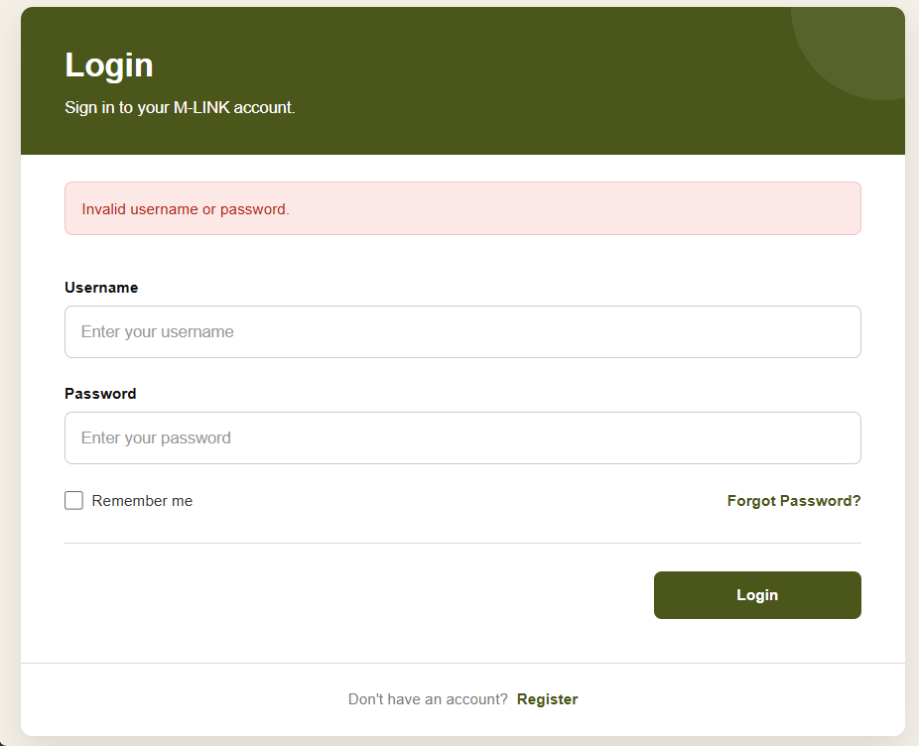
Figure 2: Login and role output evidence

6 Account Administration Output Testing

TC-ADM-01 Verify municipal staff
Field | Recorded test information
Precondition | A pending municipal staff account exists and an administrator is logged in.
Input or test data | Pending username and valid administrator confirmation password.
Execution steps | Open Verify Accounts, select Verify and confirm.
Expected output | The account becomes verified and active.
Observed output | The account was activated after confirmation.
Status | Pass

TC-ADM-02 Reject or deactivate account
Field | Recorded test information
Precondition | The target account exists.
Input or test data | Selected account and administrator confirmation password.
Execution steps | Choose Reject or Deactivate and confirm.
Expected output | The account remains stored but becomes inactive.
Observed output | The account was soft-deleted or rejected and no longer had normal access.
Status | Pass

TC-ADM-03 Restore inactive account
Field | Recorded test information
Precondition | A non-councillor account is inactive.
Input or test data | Inactive username and administrator confirmation password.
Execution steps | Open Inactive Accounts, select Restore and confirm.
Expected output | The account is returned to an authorised usable state.
Observed output | The account was restored.
Status | Pass

OUTPUT EVIDENCE PLACEHOLDER
Figure 3: Account administration output evidence
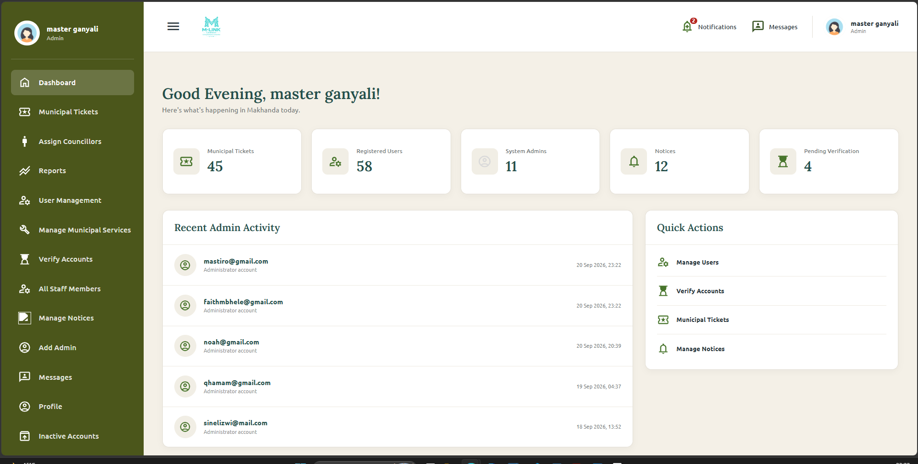
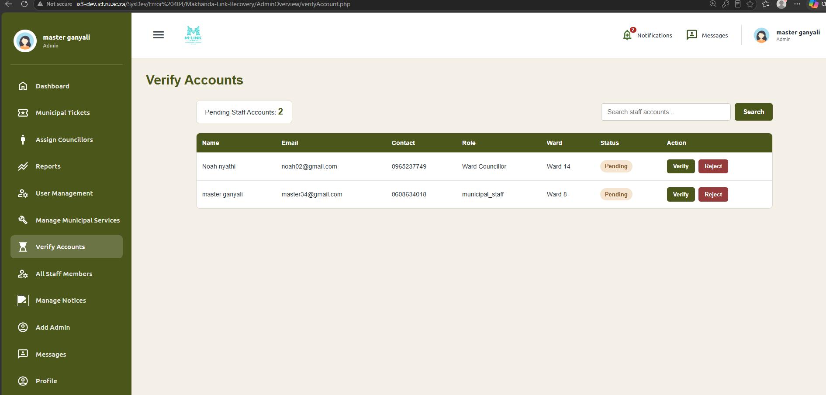
Figure 3: Account administration output evidence

7 Ward Councillor Rule Output Testing

TC-WC-01 Register councillor applicant
Field | Recorded test information
Precondition | Registration and ward data are available.
Input or test data | Valid councillor registration details.
Execution steps | Register using the Ward Councillor role.
Expected output | The account is created with verified 0 and active 0.
Observed output | The applicant remained pending and could not log in.
Status | Pass

TC-WC-02 Assign applicant to vacant ward
Field | Recorded test information
Precondition | A pending applicant and vacant ward exist.
Input or test data | Applicant, vacant ward and administrator password.
Execution steps | Open Ward Councillor Management, assign the applicant and confirm.
Expected output | The councillor is assigned, verified and activated.
Observed output | Assignment completed and councillor login succeeded.
Status | Pass

TC-WC-03 Prevent duplicate councillor assignment
Field | Recorded test information
Precondition | A ward already has a current councillor.
Input or test data | A second pending applicant and the occupied ward.
Execution steps | Attempt to assign the second applicant to the occupied ward.
Expected output | The assignment is rejected.
Observed output | The duplicate ward assignment was prevented.
Status | Pass

TC-WC-04 Restore removed councillor safely
Field | Recorded test information
Precondition | A councillor account has been removed or deactivated.
Input or test data | Removed councillor username.
Execution steps | Select Restore from Inactive Accounts.
Expected output | The account returns to pending and must be reassigned before activation.
Observed output | Direct bypass of the assignment rule was prevented.
Status | Pass

OUTPUT EVIDENCE PLACEHOLDER
Figure 4: Ward councillor assignment evidence
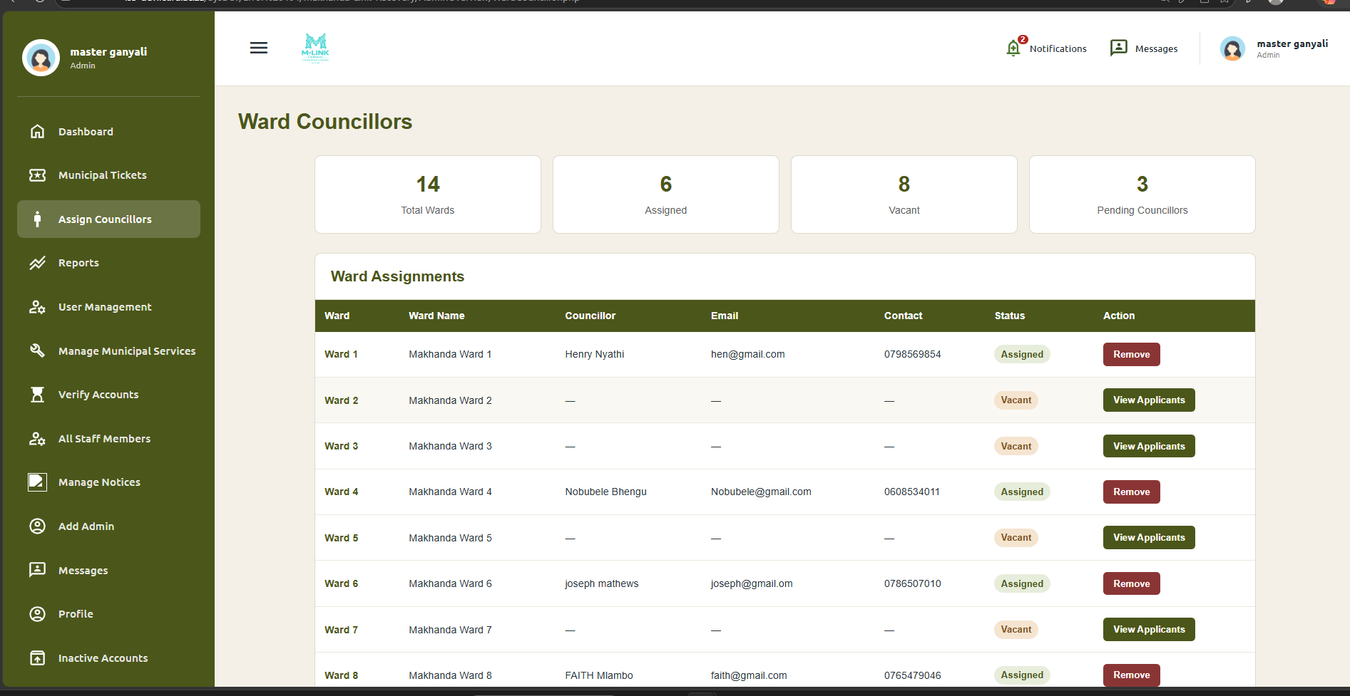
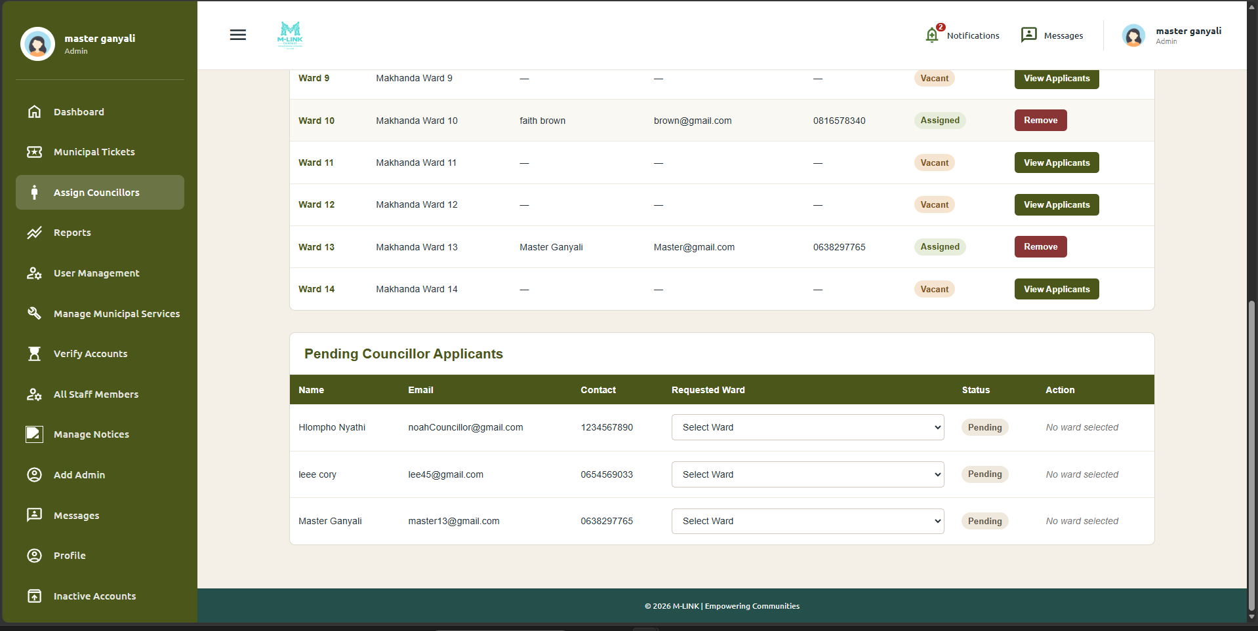
Figure 4: Ward councillor assignment evidence

8 Municipal Service Output Testing

TC-SVC-01 Add municipal service
Field | Recorded test information
Precondition | An administrator is logged in.
Input or test data | A unique service name.
Execution steps | Open Manage Services, add the service and save.
Expected output | The service is stored and displayed as active.
Observed output | The service was added and listed.
Status | Pass

TC-SVC-02 Prevent duplicate service
Field | Recorded test information
Precondition | A service with the same trimmed name exists.
Input or test data | The existing service name using the same or different letter case.
Execution steps | Attempt to add the duplicate.
Expected output | The duplicate is rejected.
Observed output | Duplicate service creation was prevented.
Status | Pass

TC-SVC-03 Service lifecycle
Field | Recorded test information
Precondition | An active service exists.
Input or test data | Updated service name and status actions.
Execution steps | Edit, deactivate and restore the service.
Expected output | Each change is saved and shown in the list and counters.
Observed output | The service lifecycle completed correctly.
Status | Pass

OUTPUT EVIDENCE PLACEHOLDER
Figure 5: Municipal service output evidence
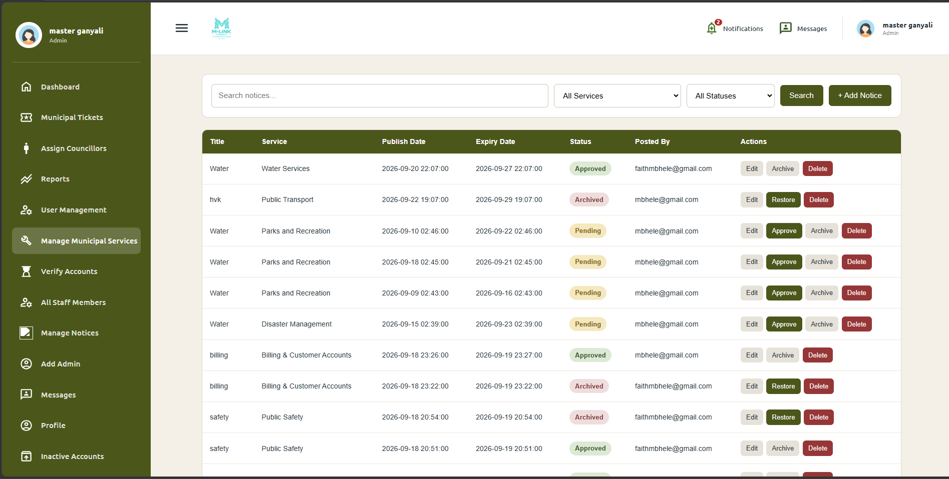
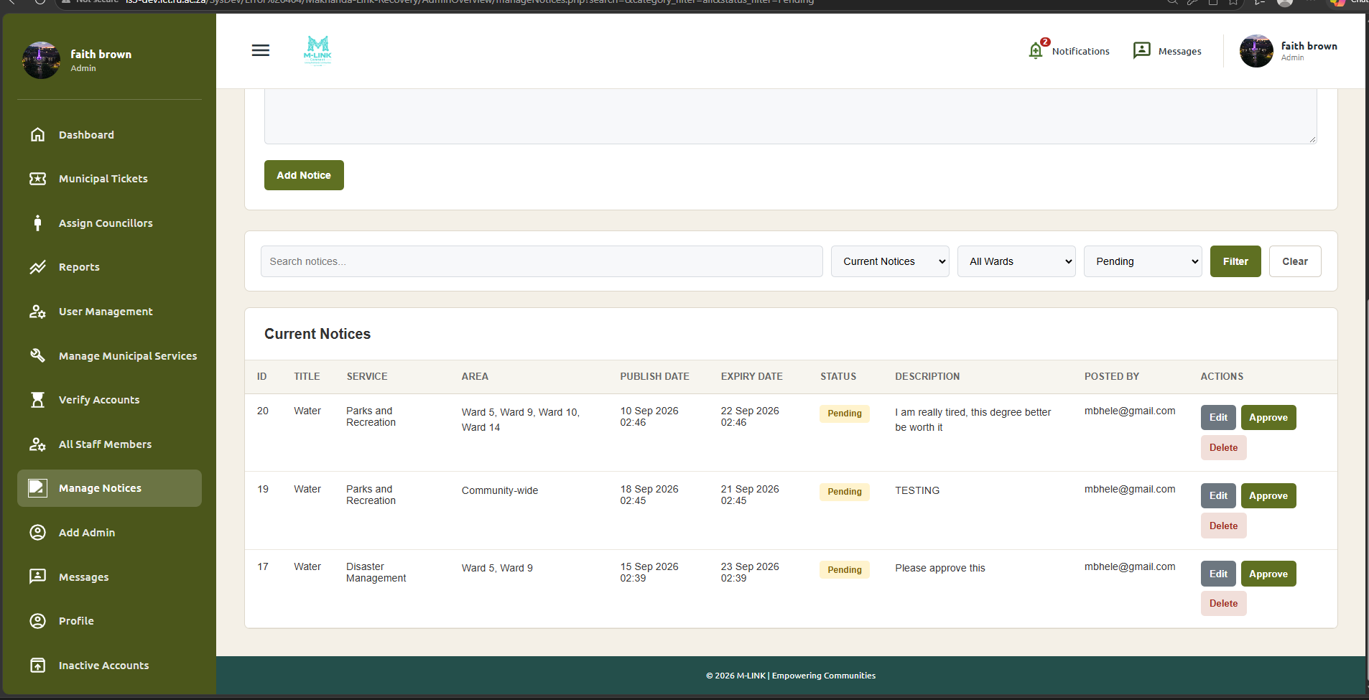
Figure 5: Municipal service output evidence

9 Notice Output Testing

TC-NOT-01 Community-wide notice
Field | Recorded test information
Precondition | An administrator and active notice category exist.
Input or test data | Valid notice details with Community-wide selected.
Execution steps | Create and save the notice.
Expected output | The notice is stored without notice_ward rows and appears as community-wide.
Observed output | The community-wide notice displayed correctly.
Status | Pass

TC-NOT-02 Ward-specific notice
Field | Recorded test information
Precondition | One or more wards are selected.
Input or test data | Valid notice details and selected ward IDs.
Execution steps | Create and save the notice.
Expected output | Correct notice_ward mappings are stored and ward names are displayed.
Observed output | The ward audience displayed correctly.
Status | Pass

TC-NOT-03 Notice filters
Field | Recorded test information
Precondition | Notices with different wards, statuses and text exist.
Input or test data | Search text, ward or status filter.
Execution steps | Apply each filter.
Expected output | Only matching notices are returned.
Observed output | The filters returned relevant notices.
Status | Pass

TC-NOT-04 Notice lifecycle
Field | Recorded test information
Precondition | A notice exists.
Input or test data | Edited data, Approve action and Delete action.
Execution steps | Edit, approve and soft-delete the notice.
Expected output | Changes are stored; the deleted notice is excluded from active listings.
Observed output | The notice lifecycle completed correctly.
Status | Pass

OUTPUT EVIDENCE PLACEHOLDER
Figure 6: Notice output evidence
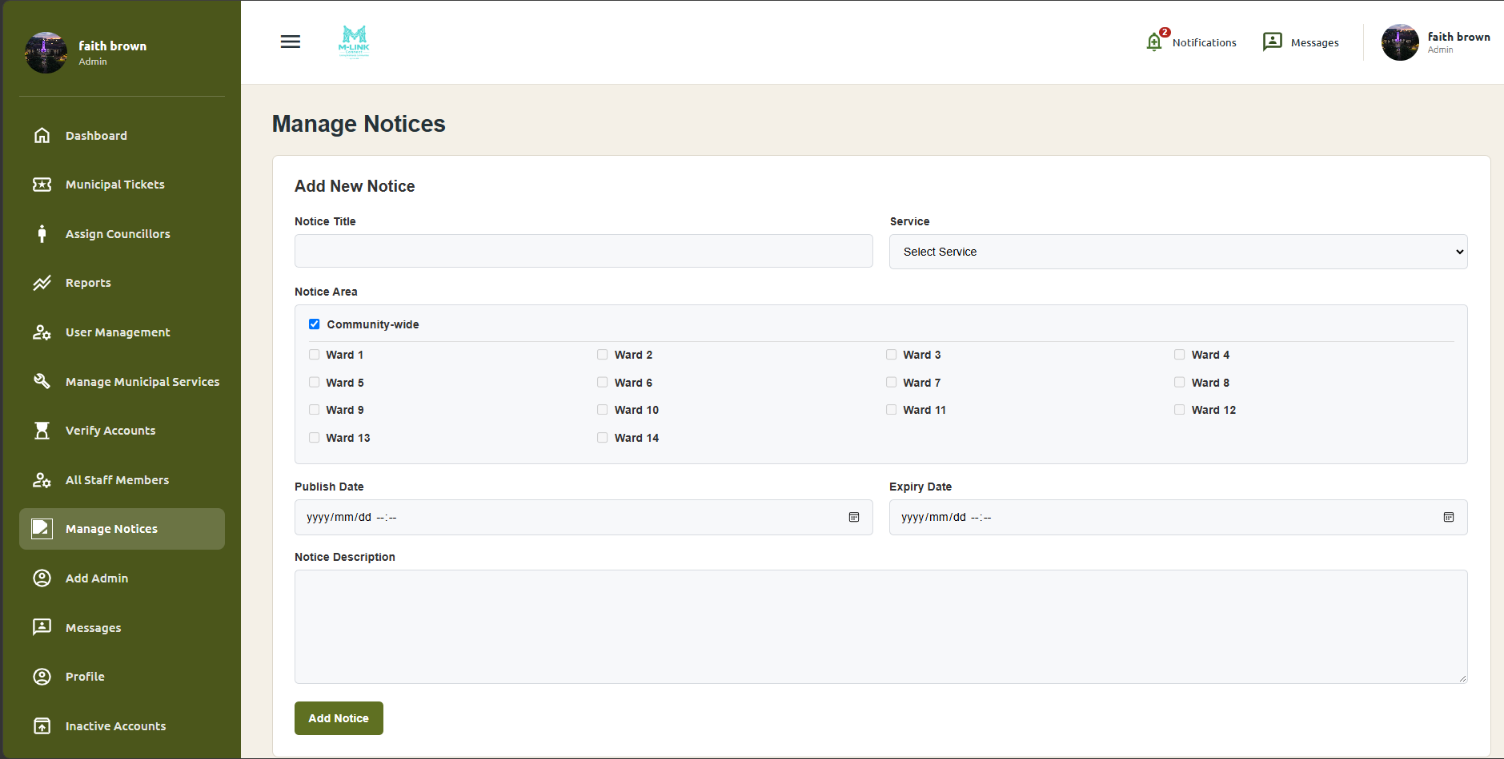
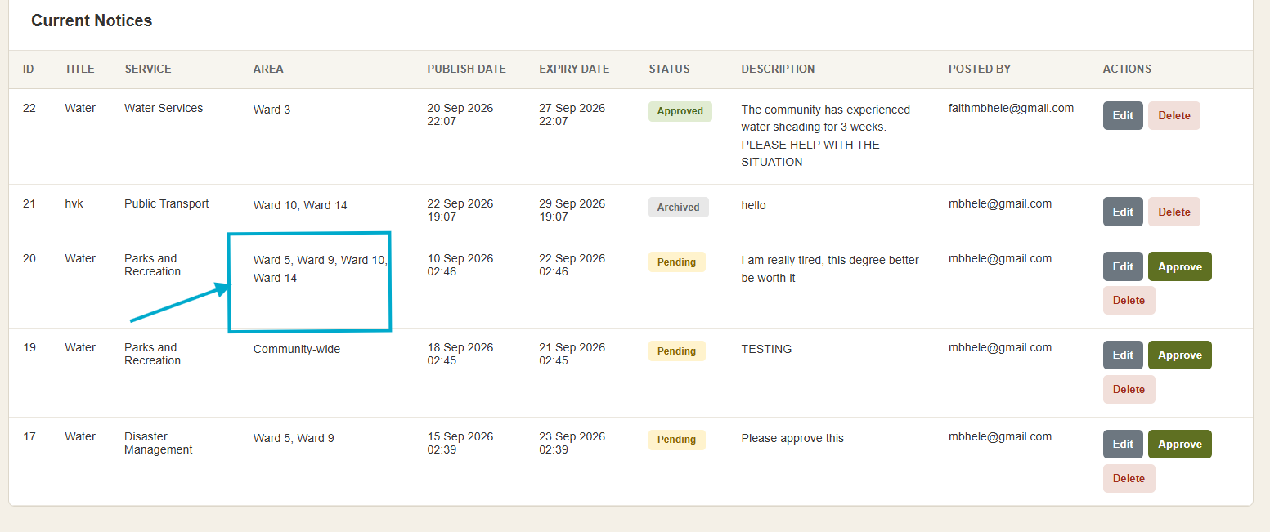
Figure 6: Notice output evidence

10 Incident Ticket Output Testing

TC-INC-01 Submit service fault
Field | Recorded test information
Precondition | An active resident, service, ward and address exist.
Input or test data | Service category, ward, address, incident description and location description.
Execution steps | Open Report a Fault, complete the form and submit.
Expected output | An incident ticket is created with the reporter, service and ward information.
Observed output | The ticket was stored and displayed with its details.
Status | Pass

TC-INC-02 View ticket management and history
Field | Recorded test information
Precondition | At least one incident ticket exists.
Input or test data | Ticket filters or selected ticket ID.
Execution steps | Open ticket management, filter the list and view details or history.
Expected output | Ticket information is displayed without query errors.
Observed output | Ticket management, detail and history data displayed successfully.
Status | Pass

OUTPUT EVIDENCE PLACEHOLDER
Figure 7: Incident ticket output evidence
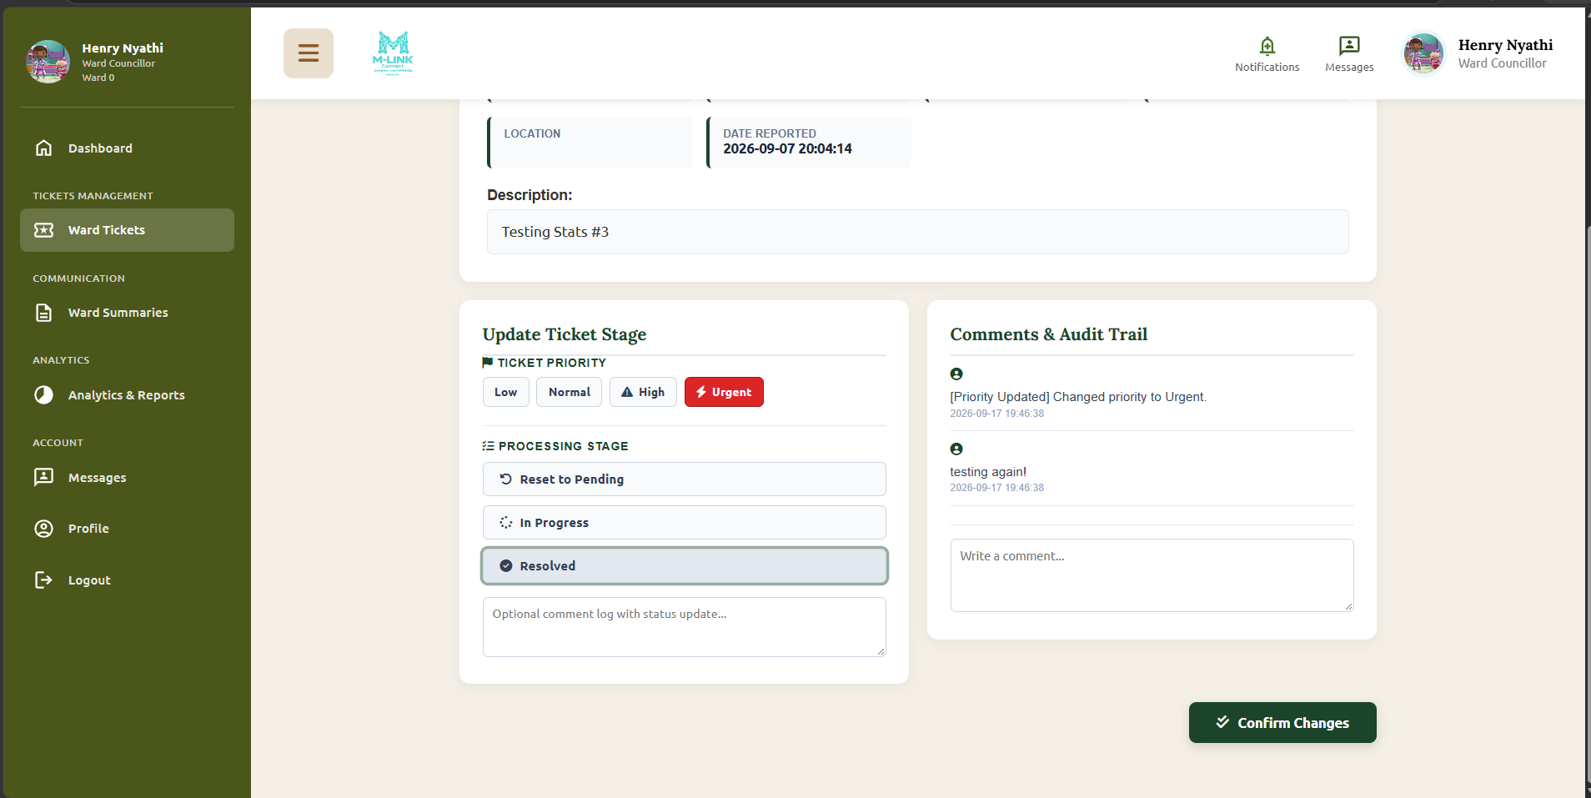

Figure 7: Incident ticket output evidence

11 Profile and Password Output Testing

TC-PRO-01 Update profile
Field | Recorded test information
Precondition | An authenticated user account exists.
Input or test data | Valid changed profile information.
Execution steps | Open Settings, change an allowed field and save.
Expected output | Validated information is stored and redisplayed.
Observed output | The profile was updated.
Status | Pass

TC-PRO-02 Change administrator password
Field | Recorded test information
Precondition | An administrator is logged in.
Input or test data | Current administrator password and valid matching new password.
Execution steps | Open Settings, submit the password change and confirm.
Expected output | New hashes are stored and the new password is accepted.
Observed output | The password was updated securely and subsequent login succeeded.
Status | Pass

OUTPUT EVIDENCE PLACEHOLDER
Figure 8: Profile output evidence
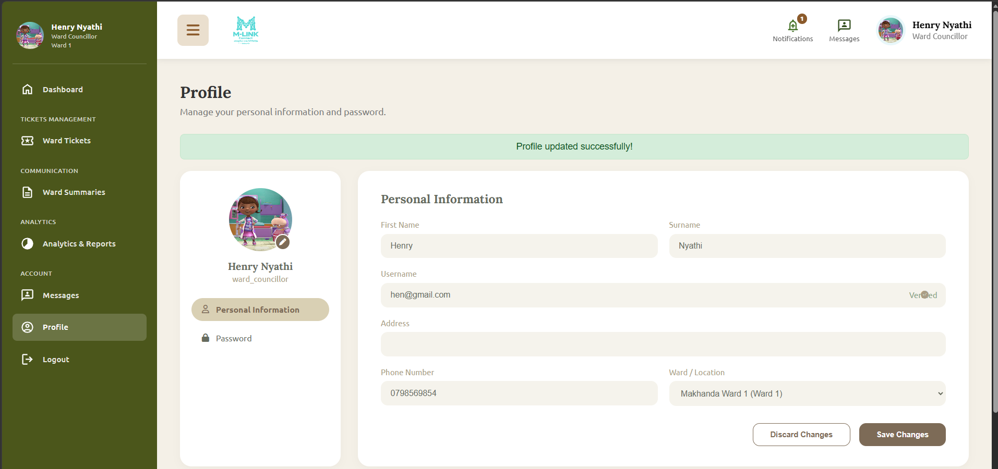
Figure 8: Profile output evidence

12 Reports Logout and Public Output Testing

TC-RPT-01 Open administrator reports
Field | Recorded test information
Precondition | An administrator is logged in and report data exists.
Input or test data | Selected report filters.
Execution steps | Open Reports and apply available filters.
Expected output | Queries execute and report results display without a fatal error.
Observed output | Reports displayed successfully after query correction.
Status | Pass

TC-LOG-01 Logout and session restriction
Field | Recorded test information
Precondition | A protected session is active.
Input or test data | Logout action followed by a protected URL.
Execution steps | Select Logout, then revisit a protected page.
Expected output | The old session no longer grants access.
Observed output | Access was refused after logout.
Status | Pass

TC-PUB-01 Public homepage output
Field | Recorded test information
Precondition | The web server and database are available.
Input or test data | Public homepage URL.
Execution steps | Open the homepage and review notices, ward links, summaries and public sections.
Expected output | The public page loads and information is displayed without login.
Observed output | The homepage and public navigation displayed successfully.
Status | Pass

OUTPUT EVIDENCE PLACEHOLDER
Figure 9: Report output evidence
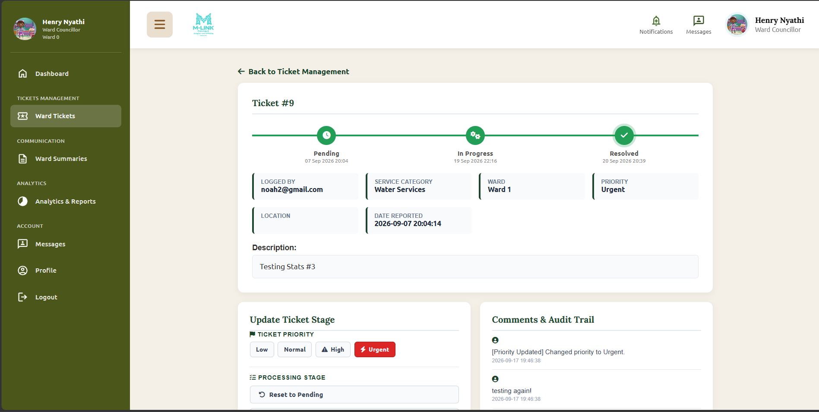
Figure 9: Report output evidence
OUTPUT EVIDENCE PLACEHOLDER
Figure 10: Logout output evidence
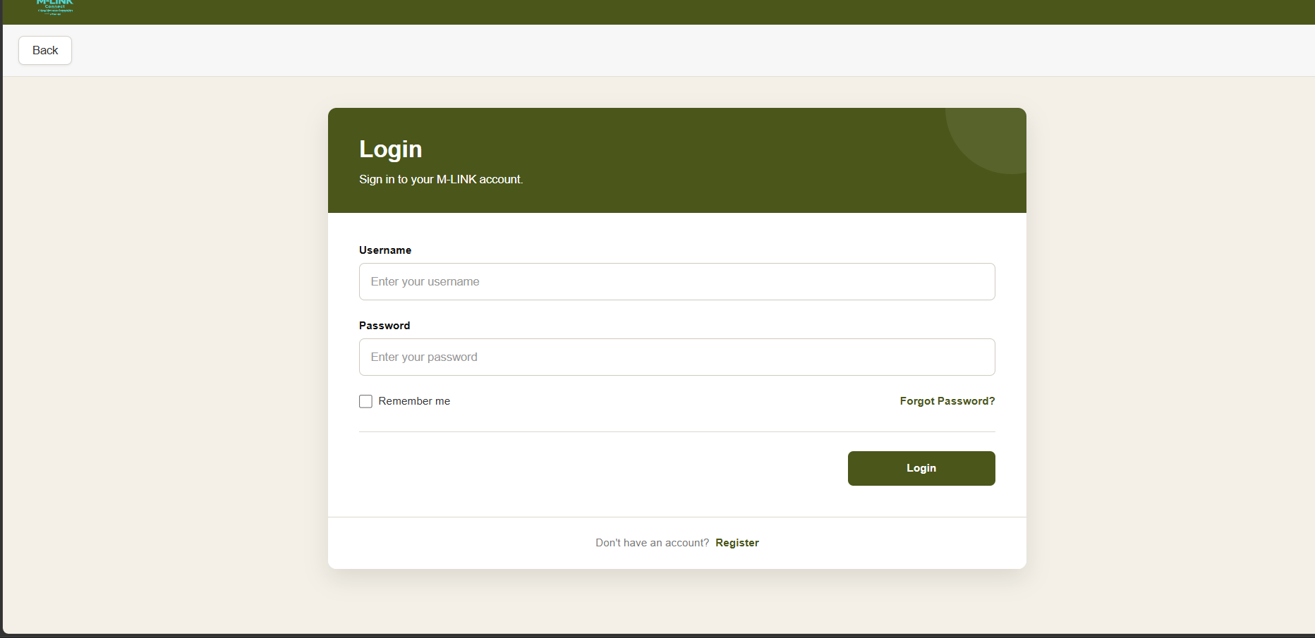
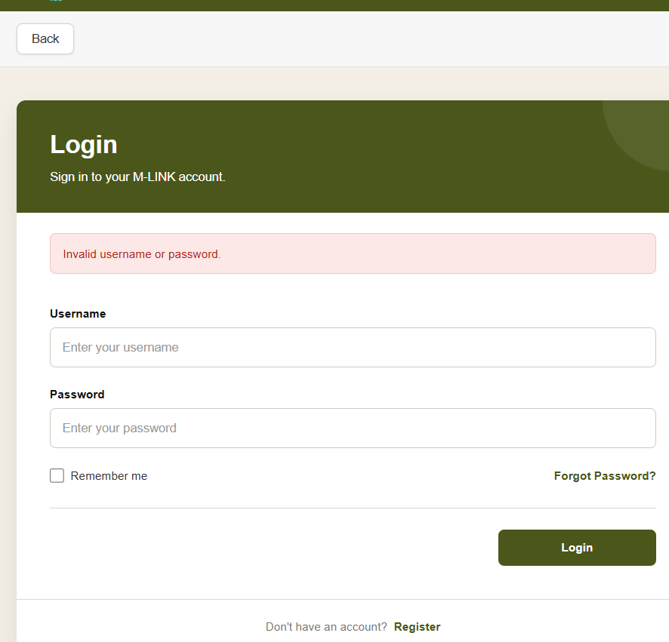
Figure 10: Logout output evidence

13 Defect Correction and Retest Evidence
Observed defect | Correction | Retest output | Status
Ticket was reported but is not appearing | Removed the invalid field from the query. | Ticket history and details loaded correctly. | Pass
Notice query referenced a ward field not stored in notices. | Used notice_ward mappings and ward joins. | Community-wide and ward-specific notices displayed correctly. | Pass
Councillor login failed because role handling was inconsistent. | Normalised role mapping and redirects. | The verified councillor reached the correct dashboard. | Pass
Organisation registration used an incorrect password field mapping. | Corrected the field mapping to the stored user password hash. | Organisation registration and login completed. | Pass
Reports produced a prepared-statement result error. | Corrected result handling and removed the unsupported measure. | The report page displayed without the previous fatal error. | Pass
Profile page required a missing include file. | Removed the broken dependency and retained the profile query. | The profile page loaded in the administrator interface. | Pass

OUTPUT EVIDENCE PLACEHOLDER
Figure 11: Defect retest evidence
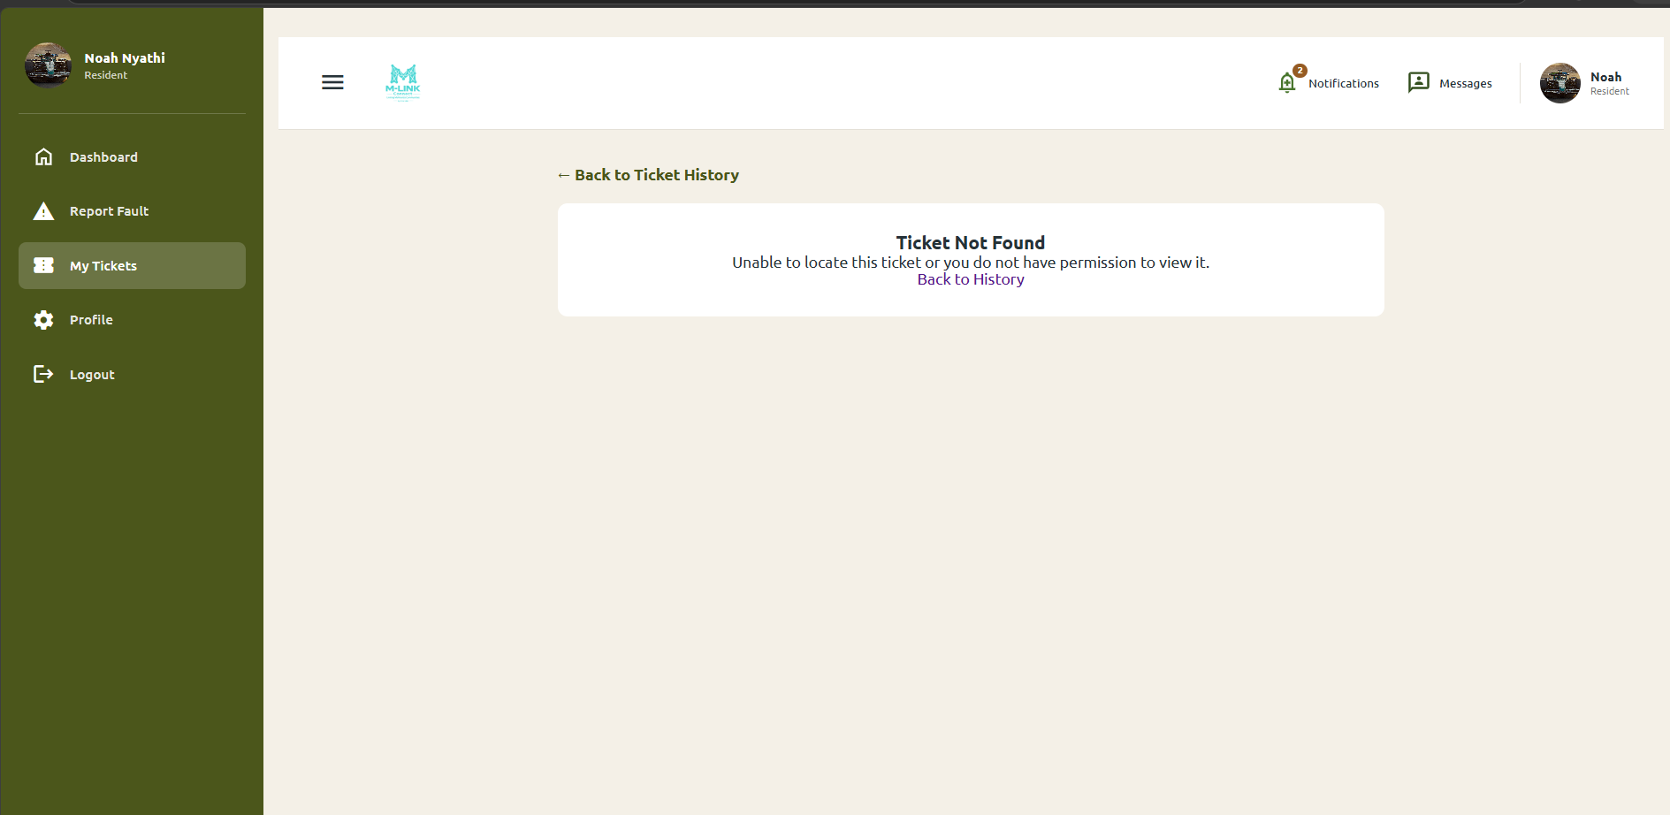
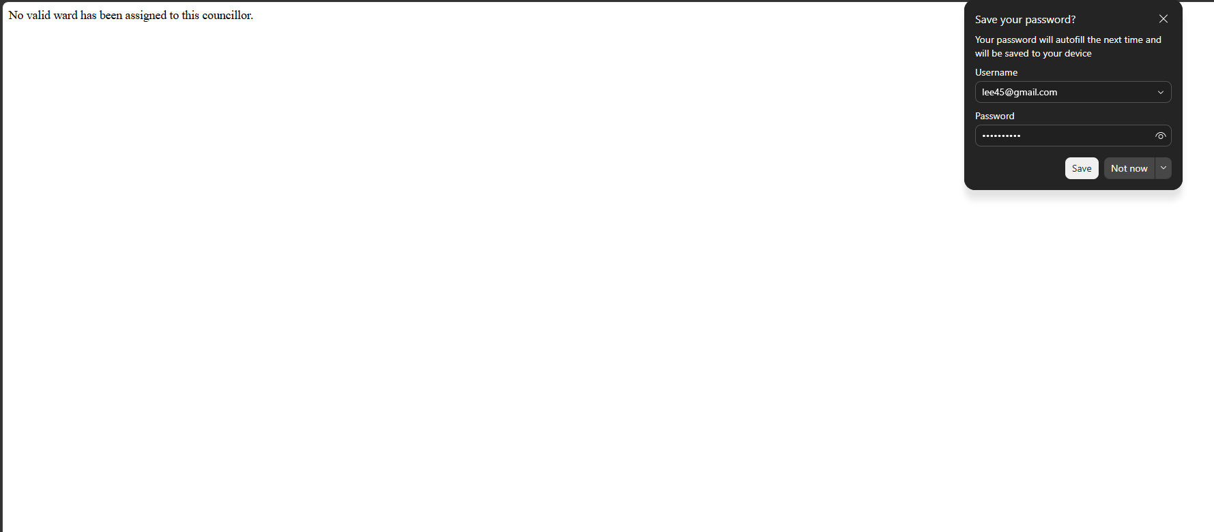
Figure 11: Defect retest evidence

14 Final Test Sign Off
The recorded execution results show that the core M-LINK functions were exercised using positive, negative, role-based and business-rule scenarios. The listed cases passed after required corrections and retesting. Final submission should include the requested screenshots, exact dates and tester initials so each result can be traced to the assessment build.
Approval item | Name | Signature | Date
Test execution reviewed | SELLO SHILALUKE | ____S.S____________ | _____20 SEPTEMBER 2026_____
Evidence screenshots checked | THANDO KALMASH | _______KALMASH_________ | _____20 SEPTEMBER 2026_____
Assessment build approved by team | CALTON MPOFU | ____MPOFU____________ | ___20 SEPTEMBER 2026_______

OUTPUT EVIDENCE PLACEHOLDER
Figure 12: Final build evidence
Insert: the system homepage or dashboard showing the tested assessment build
Figure 12: Final build evidence

Appendix A Screenshot Register
Figure | Evidence required | Inserted
1 | Registration | [ ]
2 | Authentication and access | [ ]
3 | Account administration | [ ]
4 | Councillor assignment | [ ]
5 | Municipal services | [ ]
6 | Notices | [ ]
7 | Incident tickets | [ ]
8 | Profile update | [ ]
9 | Reports | [ ]
10 | Logout | [ ]
11 | Defect retest | [ ]
12 | Final assessment build | [ ]

